**INDICATIVE GUIDE ON THE UTILISATION OF THE CHILD FRIENDLY TOOL OF THE CSP**

**SCOPE OF THE TOOL :** Facilitate the dissemination and understanding of the CSP among children and teenagers

**INTRODUCTION:**

This document is an indicative guide that can be used to support the preparation of the CSP presentation session with children, but is not a teaching manual or training module. It attempts to provide guidance and highlight the themes that appear on the tool and that are important to know and understand for children.

This document is therefore addressed to :

1. The National Child Safeguarding Committee

2. The Child Protection/Safeguarding Officer

3. The identified team who will conduct the session with children.

The tool must always be accompanied by an introductory session and for this it is necessary :

1. That the National CS Committee, with the assistance of the project managers, identify and select the project(s) where to begin the dissemination of the CSP to children,

2. To identify a team responsible for introducing the CSP to the children;

3. That he team in charge of introducing the CSP to children in the field (Educo staff or local partner) is trained by the National CS Committee and the child protection officer on the CSP and on the basic principles of child protection, particularly on the child’s rights, vulnerabilities and violence ;

4. That the team responsible for introducing the CSP to children adapts the session to its audience by choosing language and examples that are appropriate and meaningful to the audience. Try to have homogeneous groups in terms of age and sometimes gender depending on the context. For example, early childhood (2-6 years), childhood (7-13 years) and adolescence (14-18 years) and separation of girls and boys if the context or situation suggests it;

**NB** : If the tool is particularly suitable for children who are at least 12 years old, it can be used with younger children with appropriate guidance and explanation.

The tool alone is not useful. It is not enough to simply publish the posters on the walls of a school, it would be almost dangerous to do so because without explanation the tool could be confusing and could be misinterpreted.

**THE TOOL**

We will now go through the 2 posters and provide you with examples (non-exhaustive and non-mandatory) of content and sources that you can use either in the preparation phase or during the session to introduce CSP to children.

**It is essential that each country office feeds into this guide by integrating its own examples and sharing interesting sources that may be useful to other country offices. Both, the tool and the guide are developed at Head Office and are therefore global in nature, but it is very important that the sessions are adapted to the contexts and enriched by the skills, knowledge and tools that already exist locally.**

The Tool consists of 2 posters with text and drawings. The 2 posters should always be shown and displayed together.

Poster 1 deals with the issue of children's rights, existing typologies of violence and how to report cases of abuse at Educo.

Poster 2 is a simplification of the Educo’s Code of Conduct.

**THE MAIN THEMES OF POSTER 1 :**

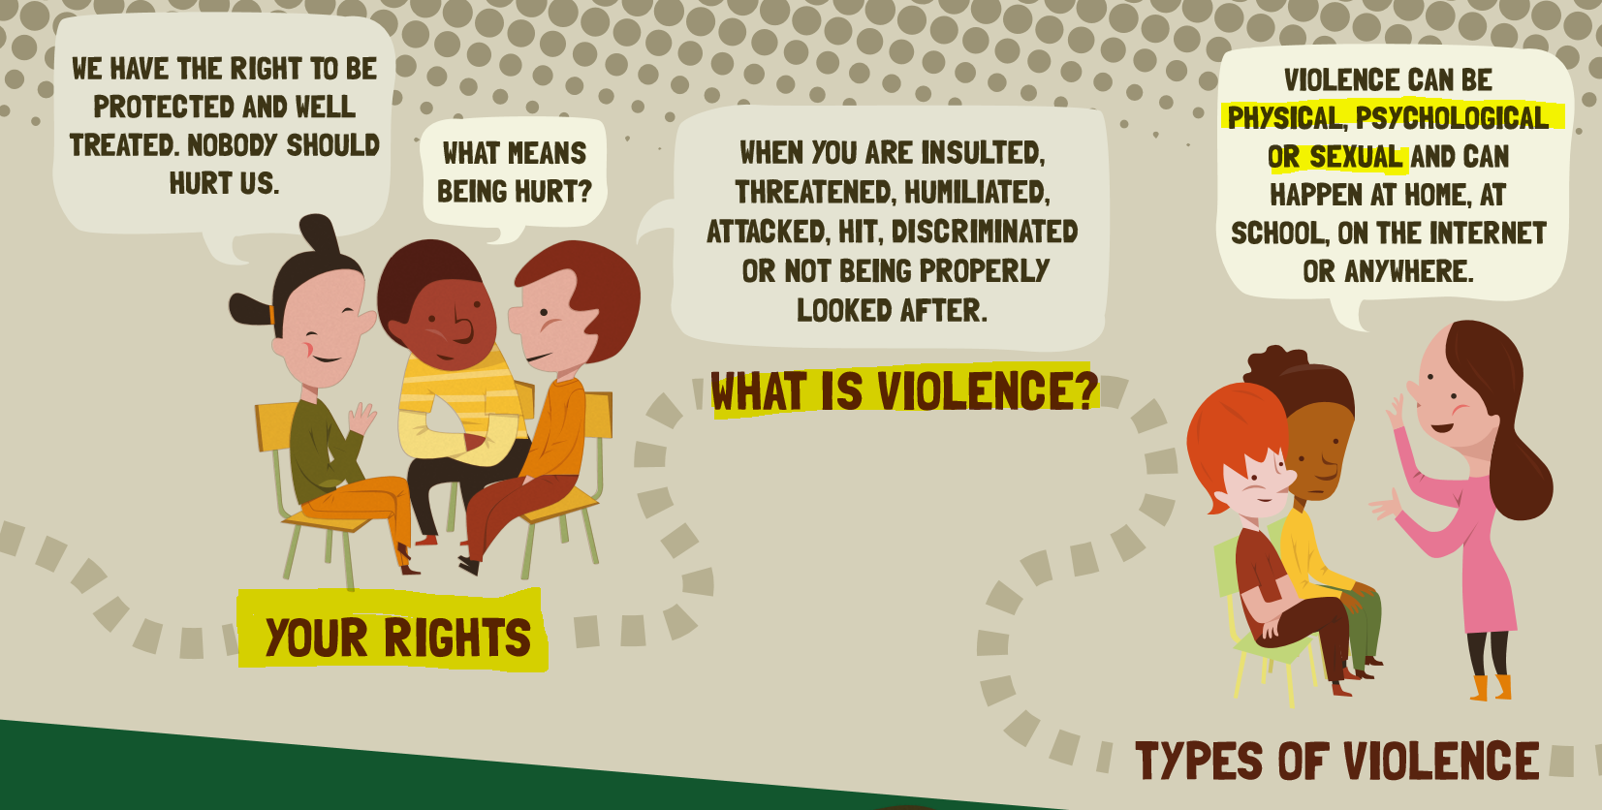

1. **Children’ Rights**

The team in charge of the CSP's outreach to children must be familiar with the International Convention on the Rights of the Child and must be able to speak about it in public:

* **Unicef website explaining what children's rights are and link to download the UNCRC** <https://www.unicef.org/child-rights-convention/child-rights-why-they-matter> (site also available in French and Spanish and possibility to download the charter of the rights of the child on the same page)
* **Official website of the Office of the United Nations High Commissioner for Human Rights (OHCHR)** <https://www.ohchr.org/en/professionalinterest/pages/crc.aspx>
* **Examples of child-friendly videos that introduce children's rights and that can be used** <https://www.youtube.com/watch?v=HHNfaPuoZHM> (English, *Australian Human Rights Commission*)

<https://www.youtube.com/watch?v=Gb_2JOdiuZs> (French, *Amnesty France*)

<https://www.youtube.com/watch?v=lbGOmqP7yuc> (Spanish, *Unicef*)

<https://www.youtube.com/watch?v=sGUWhHaNsko> (Spanish, *Unicef*)

1. **Vulnerability and violence/s**

The team responsible for presenting CSP to children must be able to explain what violence is and its different forms:

* **Examples of child-friendly videos that explains what is violence/abuse** <https://www.youtube.com/watch?v=Tl4hmBoJOdI> (French, *Ligue française des droits de l’enfant*)

<https://www.youtube.com/watch?v=5U1N8f8zLrw> (Spanish)

<https://www.youtube.com/watch?v=6kcKX2In0B0> (English, *Centre of Disease Control and Prevention of USA*, also available in Spanish)

<https://www.youtube.com/watch?v=5U1N8f8zLrw> (Spanish)

* **Examples of child-friendly videos on the different types of violence**

<https://www.youtube.com/watch?v=KhSixhVvbi4> (English, *Unicef Philippines*)

<https://www.youtube.com/watch?v=o9usl_emisA> (English)

<https://www.youtube.com/watch?v=QBR1kYcRbig> (Spanish)

* **Examples of child-friendly videos on gender based violence**

<https://www.youtube.com/watch?v=MBZTPBrPsUk> (français, vidéo explicative sur l’égalité de genre, *Unicef*)

<https://www.youtube.com/watch?v=FUbA0VTykRk> (Español, igualdad de genero, *Unesco*)

<https://www.youtube.com/watch?v=j85fGU3PeeY> (English, gender equality, *OECD*)

<https://www.youtube.com/watch?v=JKHAmvcHSPk> (English, *Aflatoun International*)

<https://www.youtube.com/watch?v=zQ1YvoeBV2g> (français, vidéo explicative sur les violences basées sur le genre, *Save The Children*)

<https://www.youtube.com/watch?v=LAGTz0DMMEw> (français, sensibilisation contre la violence basée sur le genre, *UNFPA Sénégal*)

<https://www.youtube.com/watch?v=CFNF_6u7cqk> (English, *UNFPA*)

<https://www.youtube.com/watch?v=H7YomzQNiE8> (English, *Generation for Peace, Uganda*)

<https://www.youtube.com/watch?v=F6iqghLCuU8> (Spanish, violencia de genero para pequeña infancia, *Comunidad de Madrid*)

1. **Child Safeguarding cases notification, response and follow-up process**

**NB:** The selection and/or the development of communication channels for case reporting is a critical process that must be conducted in parallel with the CSP’s outreach to children. Hence the importance of choosing in advance the projects where you are able to ensure the follow-up of case notifications and by the same logic the importance of choosing a communication channel that you are able to consult every 24 hours as requested by the CSP .

**Once the communication channel(s) have been established, they should be inserted in the empty insert at the bottom of poster 1 (e.g. email, phone number, location of a box etc.).**

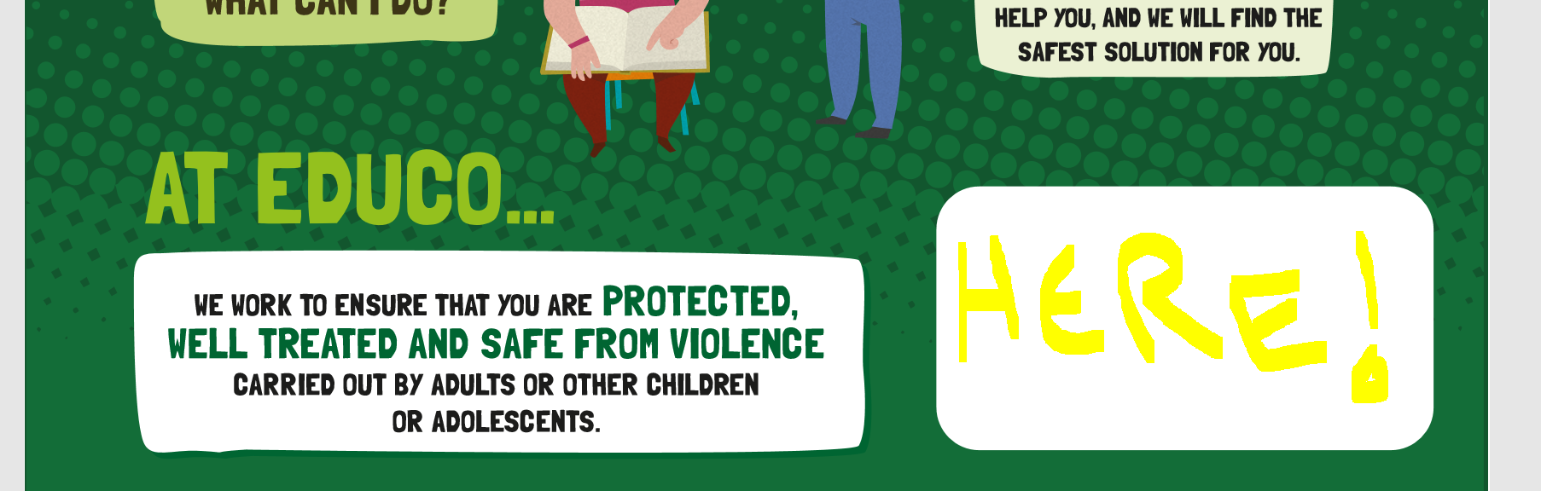

**THE MAIN THEMES OF POSTER 2 :**

1. **The people concerned by Educo's CSP and Code of Conduct:**

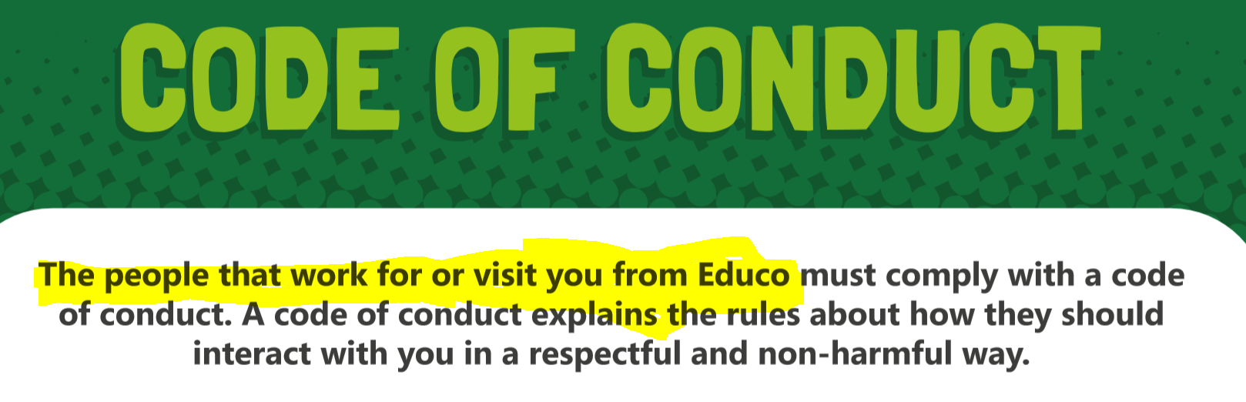

Refer here to Chapter 4 of the CSP "SCOPE" and clearly explain to children who are the persons who have a duty to comply with this Code of Conduct.

**NB** : it is very important to spread a clear message: no one has the right to hurt a child, not even another child. If the session is focused on Educo's CSP it is important that children understand that the right to be well treated is applicable everywhere, not just in an Educo’s activity, and that it must be respected by all adults and all children!

1. **All violence related to sexuality**

The majority of the prohibitions in the Code of Conduct relate in one way or another to the field of sexuality, and we are aware that this is a sensitive topic. Especially with children we know little about and assessing the level of detail to be provided can be difficult in a single CSP presentation session. Here are some suggestions on how to approach the topic.

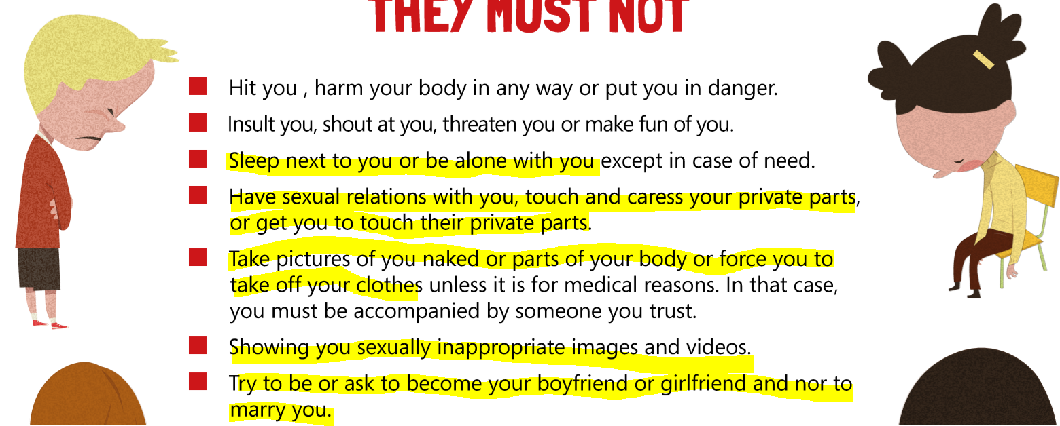

* **Examples of videos on child autonomisation and the prevention from sexual abuse**

<https://www.youtube.com/watch?v=xth8t0y_AFQ> (Spanish)

<https://www.youtube.com/watch?v=PVAFdPAA6qw> (French)

<https://www.youtube.com/watch?v=wx-E686t8hQ> (French, *Observatoire de la Jeunesse, Belgique*)

<https://www.nspcc.org.uk/keeping-children-safe/support-for-parents/underwear-rule/> (English, addressed to early childhood, **song exercise)**

* **Examples of child-friendly videos about the principle of consent**

https://www.youtube.com/watch?v=h3nhM9UlJjc (ENG)

<https://www.youtube.com/watch?v=qhKoCFQ3Yog> (SPA)

<https://www.youtube.com/watch?v=S70PvCqtXwU&t=30s> (FRE)

* **How to talk about risks related to pornography ?**

<https://www.internetmatters.org/fr/issues/online-pornography/protect-your-child/#age-appropriate_conversations> (FR)